Table of Contents

1 Introduction ..................................................................................................................................1

2 Problem Statement........................................................................................................................1

3 Objectives.....................................................................................................................................2

4 Methodology ................................................................................................................................3

4.1 Requirement Identification ..........................................................................................................3

4.1.1 Study of existing system...............................................................................................4

4.1.2 Requirement collection ................................................................................................4

4.1.2.1 Hardware Requirements ..........................................................................4

4.1.2.2 System Requirements ................................................................................5

4.2 Feasibility Study .................................................................................................................................5

4.2.1 Technical .............................................................................................................................5

4.2.2 Operational ........................................................................................................................5

4.2.3 Economical..........................................................................................................................6

4.3 High level Design of System ...........................................................................................................7

4.3.1 System flowchart .............................................................................................................7

5 Gantt chart ....................................................................................................................................8

6 Conclusion ....................................................................................................................................9

6.1 Expected Outcome .............................................................................................................................9

6.2 Wireframe ...........................................................................................................................................10

7 References ...................................................................................................................................10

## **INTRODUCTION**

In today's tech era, Internet has become much popular around the world. Almost all the devices, which are known as smart device, can connect to the internet and access data from any corner of the world. There was a time when people used to waste their valuable time just to get a piece of information. Now the technology is more advance then compare to any previous times. One of the blessings of technology is web application. It allows users to interact with the system from anywhere as long as they are connected to the internet [1.1].

Here, "Online Bus Ticket System" is completely a web application. As we already discussed above that internet has made the user’s interaction through the system easier, so this web application can connect to respective servers for accessing data which will surely help users to purchase the bus ticket or reserve their seats online without waiting on queue. Moreover, in recent decays peoples are like to travel to get some relief from their monotonous life. So, they want to travel without any hesitations. In this modern tech era they want a system that will enhance the portability, accessibility as well as user friendly. So here, we are going to implement a web system, which we already stated above, having all the features that will make it more user friendly and accessible.

In this system, we can provide different types of buses. Here, we can manage all types of passenger data & bus data. All details that are related to traveling like fare details, seat availability, details of booking, bus details, seating arrangement, inquiry, etc. The charges are different for different buses. The charges also depend on the distance the customer wants to travel. In this system, we can provide the features to the passenger like the passenger could choose the available seats themselves. This reservation system also provides the admin facilities to send Email & SMS.

This website has various kinds of information that helps regarding booking of tickets. Users will be able to search the bus availability, the exact fare, the arrival and departure time of the bus.

# **PROBLEM STATEMENT**

The Manual bus rental system provides services only during office hours. So, customers have limited time to make any transactions or reservation of the buses. The existence of the online bus rental systems nowadays has overcome the limitation of the business operation hour. However; there is still a few numbers of these online bus rental systems in Nepal and most of the systems offered reservation service for tourists or traveler. Besides that, there are some customers who faced a problem in choosing bus to be rented which suitable with some of the important requirements.

1. To rent a bus a prospective renter must first go to the nearest office to register as a client.
2. Buses that provide difficulties to rent out are normally advertised in local or national newspaper.it involves a lot of paper work and consumes time.
3. With the Dashain Tika hardly a week away, the unavailability of bus tickets has hit the out bound passengers.
4. Passengers complain of being shortchanged after bus fare hike.
5. Choosing right Bus
6. Single ticket for multiple passenger
7. Needs a lot of working staff and extra attention on all the records.
8. In existing system, there are various problems like keeping records of items, seats available, prices of per/seat and fixing bill generation on each bill.
9. Finding out details regarding any information is very difficult, as the user has to go through all the books manually.

# **OBJECTIVES**

The proposed web-based system has the following features that will be included in the Online ticketing System. With the proposed system, the achievable advantages are as follows:

1. To view transaction and reservation,

2. To view updated accommodation details,

3. To view vehicles with affordable pricing the rental pricing for each type of vehicles.

4. To post suggestions, comments, and complaints the registered and unregistered users are able to post their suggestions, comments and complaints.

# **METHODOLOGY**

## **4.1** **Requirement Identification**

Waterfall is a linear, sequential approach to software development that involves completing each phase of the project in order before moving on to the next. This method works well when the requirements are well defined and there is little room for changes

**Maintenance**

**System**

**Design**

**Requirement**

**Analysis**

**Implementation**

**Testing**

**Deployment**

Fig (4.1). Waterfall Model

### **Study of existing System**

Bus Reservation Systems that were suggested till now, are not up to the desired level. In order to build the system, all the processes in the business should be studied; System study helps us under the problem and needs of the application. System study aims at establishing requests for the system to be acquired, development and installed.

Existing Systems:

* Bussewa
* Bus Sewa Nepal

It involves studying and analyzing the ways of an organization currently processing the data to produce information. Analyzing the problem thoroughly forms the vital part of the system study. In system analysis, prevailing situation of problem is carefully examined by breaking them into sub problems. Problematic areas are identified and information is collected. Data gathering is essential to any analysis of requests. It is necessary that this analysis familiarizes the designer with objectives, activities and the function of the organization in which the system is to be implemented [3].

* **Disadvantages of Existing system:**
* Existing system is totally on book and thus a great amount of manual work has to be done. The amount of manual work increases exponentially with increase in services.
* Needs a lot of working staff and extra attention on all the records.
* In existing system, there are various problems like keeping records of items, seats available, prices of per/seat and fixing bill generation on each bill.
* Finding out details regarding any information is very difficult, as the user has to go through all the books manually.
* Major problem was lack of security.

### Requirement Collection**:**

To collect the requirement, firstly we studied the previous booking system and management system by interviewing the passengers and local peoples form Kathmandu. According to those, there are lots of problem like: Timing and payment.

### 

### **4.1.2.1** Hardware Requirements:

* + 1. PC with Pentium IV processor or above
    2. 512MB RAM or above
    3. 25 GB Hard Disk or above

### System Requirements:

1. Operating System: Windows 7 or above
2. HTML, CSS, JS, PHP, MySQL
3. Apache server
4. Chrome, Microsoft edge, Firefox etc.
5. VS code or any

## **Feasibility Study:**

When a project is started an initial investigation is carried out. During this phase of study users need has recognized and other requirements are determined. Once the problem has been defined a study is carried out to select the best system i.e., a feasible system that meets performance requirements. So, Feasibility is the determination of whether or not a project is worth doing and the process followed in making this determination is called a feasibility study. In order to conduct the feasibility study, we have two districts, but inter related types of feasibility, these are technical feasibility, operational feasibility and Economical feasibility.

The objective of the feasibility study is not only to solve the problem but also to acquire the sense of its scope. During the study, the problem definition is crystallized and aspects of the problem be included in the system are estimated. Cost and benefits are estimate with greater accuracy at this stage. There keys constraints are involved in feasibility study.

### **Technical:**

System is said to be favorable when the information meets the technical requirements of an organization. It checks whether the system work properly when developed & installed, and also checks if there exist any barriers to implement the system. Apart from these, there several points to focus on the technical analysis.

Technical staff is to take care of the server and the database for this new bus ticketing system. If the system has any problem occur then technical staff will solve the problem immediately so that will affect the business operation of the company. Since this is a new online system so we need to add computer, some necessary of the hardware and software for running this new system is needed

* + 1. **Operational:**

The proposed system is operationally feasible as it solves the inefficient manual ticketing service, very easy for the end users to operate, can be used effectively after it has been developed and allow the Aileron Community Theatre (ACT) staff to perform its operation efficiently. Therefore, the new system increases the performance as it satisfies customers’ needs through timely and efficient service delivery. Operational feasibility deals with study prospectus of the system. This system operationally eliminates all the tensions of the tensions of the admin and effectively tracking the project process. This kind of automation will surely reduce time and energy, which previously consumed in manual work. Based on the study, the system is provided to be operationally feasible.

Processed feasibility is beneficial only it meets the user requirement. This system will certainly be supported since it produces good results lots of work

* + 1. **Economical**

Economically, the proposed automated system will eliminate the time and money spent for process of manually booking ticket, reduces the consumption of paper and increases customers’ satisfaction. The cost of this system is development cost which is related to purchasing of computers and developer salary, which is less than the benefit to be obtained after the system is deployed. Economic feasibility or cost benefit is an assessment of the economic justification for a computer system project. Since the system is a web based, my number of employers can use this tool from anywhere and anytime. Not only the cost of hardware, software etc is considered but also benefits in the form of reduced cost are considered. The immigrant can be applying for the VISA online without going to foreign exchange.

* 1. **High level Design of System**

**4.3.1 System Flowchart:**



Load main value

Enter Valid password

Enter to admin

Enter detail for the task

Verify detail

Data base

Another task

Display report

Update detail and process report

Print report



Fig (5.1) System Flowchart

1. **GANTT CHART:**

|  |  |  |  |  |
| --- | --- | --- | --- | --- |
| **ACTIVITIES** |  | |  |  |
| **I** | **II** | **III** | **IV** |
| Project Analysis |  |  |  |  |
| Proposal submission |  |  |  |  |
| Component collection |  |  |  |  |
| Design Verification |  |  |  |  |
| System Validation |  |  |  |  |
| Coding &  Implementation |  |  |  |  |
| Unit testing |  |  |  |  |
| Final testing |  |  |  |  |
| Documentation |  |  |  |  |
| Final Project  Submit |  |  |  |  |

Fig (6) Gantt Chart of Online Bus Ticket System

1. **CONCLUSION**

Nowadays, bus agencies are taking important role in transportation, and to make reservation reliable they need a strong system that they will make reservation easier, faster and safer. This project designed to meet requirements of a bus reservation system. It has been developed in HTML, PHP, CSS, JAVASCRIPT and database has been built in MySQL. By using this application, the company can provide reservation services and information to their customers without the limitation of office hours or manpower. Not only does it let customers book trips around the clock from any location with an internet connection but it is also designed for use by the company to internally manage their business processes; minimizing human errors and overcoming difficulties and problems that arose in the previous system.

**6.1 Expected Outcome**

After the completion of this project, we will expect there will be two types of users.

Firstly, the **Admin** who have all the facilities like:

* To check user account verified or not.
* Update detail about ticketing.
* To manage payment method.
* To view statement and print.
* To solve user’s query’s

Secondly, the **Users** who have facilities like:

* Book ticket as per their required time and date.
* To view different buses and their facilities as per their choice
* To give feedback for further improvements purpose or future reference purpose.
* Change password,
* To view ticket, download and print.

## **Wireframe:**

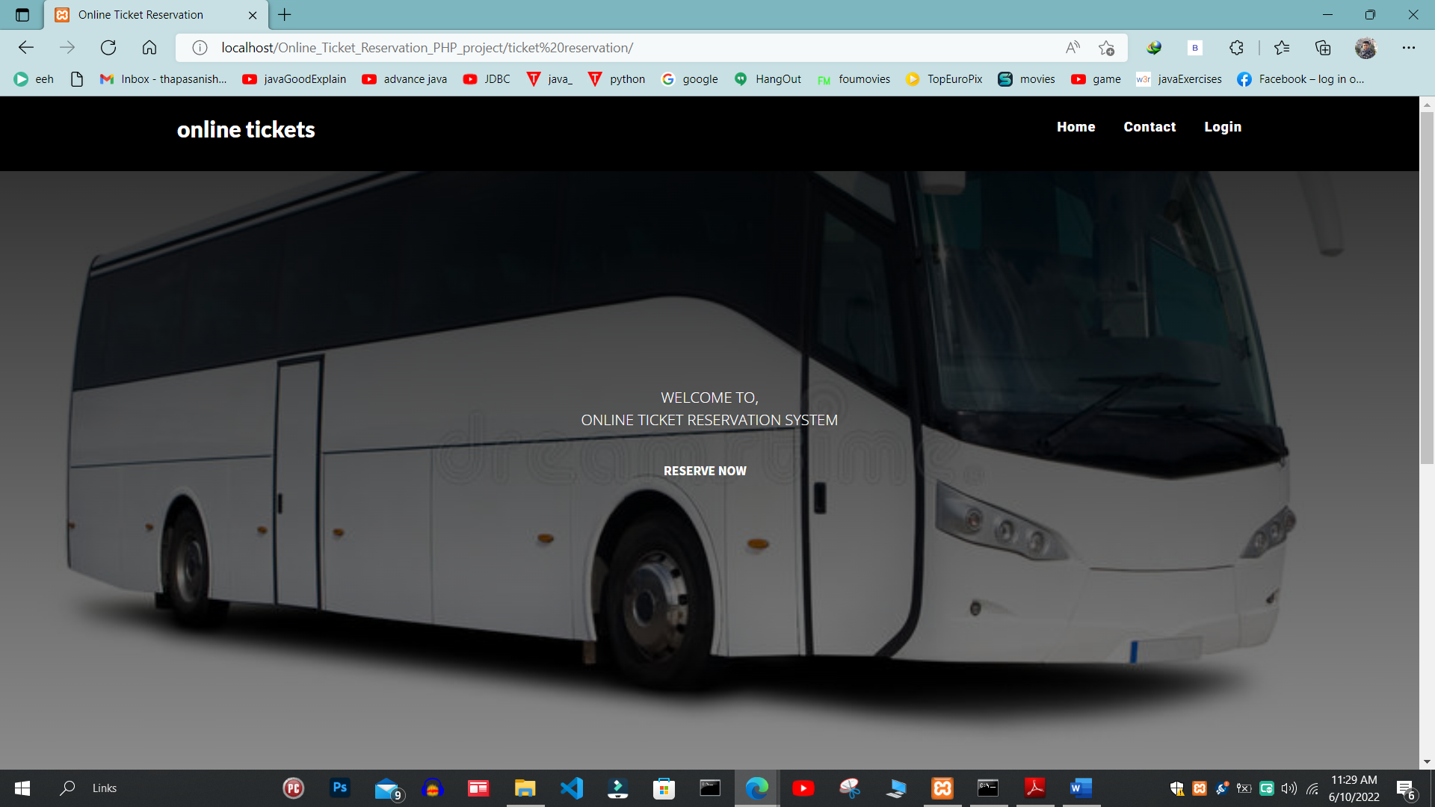

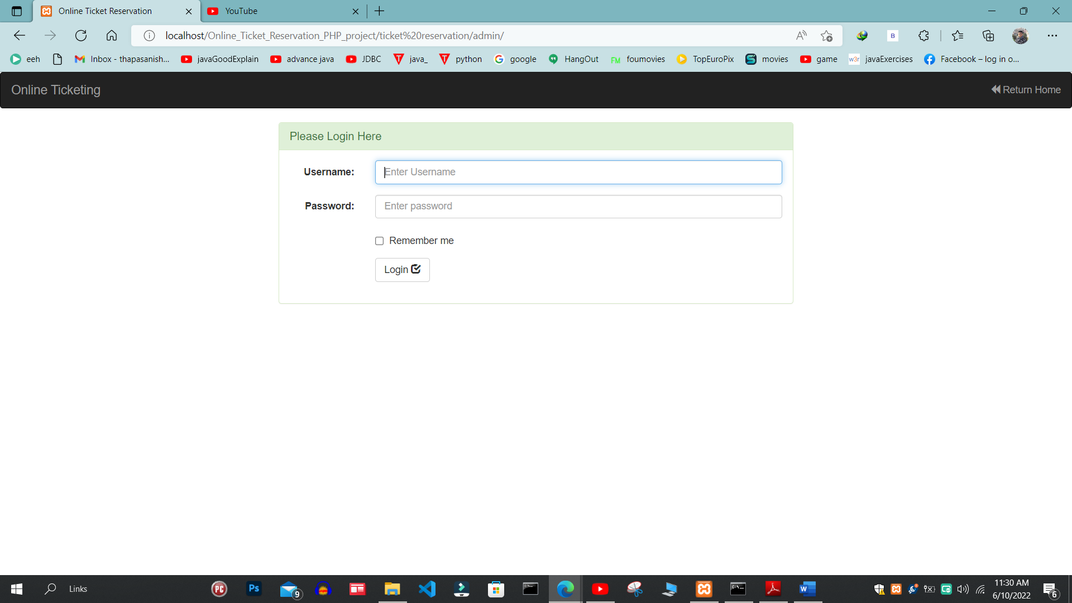

**7. REFERENCES**

[1.1][**https://www.google.com/url?sa=t&rct=j&q=&esrc=s&source=web&cd=&cad=rja&uact=8&ved=2ahUKEwijkIO8qNz2AhURAd4KHTAaC2YQFnoECAUQAQ&url=https%3A%2F%2Fcore.ac.uk%2Fdownload%2Fpdf%2F234644905.pdf&usg=AOvVaw39vZzJuOPQ6_F2eE75oSpg**](https://www.google.com/url?sa=t&rct=j&q=&esrc=s&source=web&cd=&cad=rja&uact=8&ved=2ahUKEwijkIO8qNz2AhURAd4KHTAaC2YQFnoECAUQAQ&url=https%3A%2F%2Fcore.ac.uk%2Fdownload%2Fpdf%2F234644905.pdf&usg=AOvVaw39vZzJuOPQ6_F2eE75oSpg) **-PDF**

[4.3.1] Dataflow diagram available at: [Online Bus Ticket Reservation System (researchgate.net)](https://www.researchgate.net/publication/326468848_Online_Bus_Ticket_Reservation_System)